

Circuit Playground Express

*Our first program: Making a light blink*

This project introduces programming the Circuit Playground Express using MakeCode (instructions on downloading, uploading, saving, and running your MakeCode programs are in the "Importing and Downloading Files" lesson).

***Note:*** *These lesson plans include working code for each lesson, but do not include comprehensive instructions on how to write code in MakeCode. Searching the Web should turn up a large amount of tutorial content that will help you get started. Pacific Northwest National Laboratory also offers regular in-person MakeCode workshops for educators; if you are interested in attending one please contact Liz Stephens at elizabeth.stephens@pnnl.gov.*

Blinking with an on-board LED

For our first program, we will make a light blink on and off – first one of the lights embedded on the Circuit Playground Express, and then one that is wired up to one of the programmable output pads.

First, introduce MakeCode. Explain how blocks can be grabbed out of the list, and how a program can be assembled from them to tell the Circuit Playground Express what to do. Have you students begin a new project, and insert a "Set pixel color at X to Y" block into the "Forever" loop to set one of the pixels to the color of their choice:

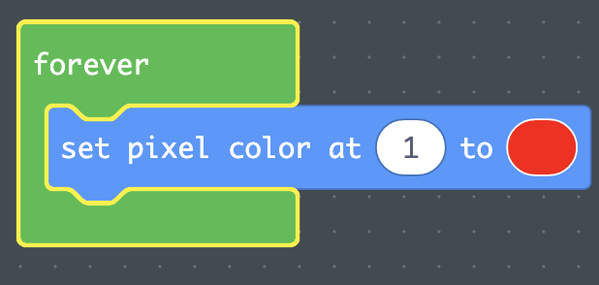

Note that as soon as the block is added, the light at the chosen position in the left-hand sidebar turns on – this would be a good time to explain that the Circuit Playground Express in that sidebar will run whatever program is currently loaded, which is a great way to test code.

Try changing the number in your block. What happens? Have you students put in numbers from 0 to 9 and node the positions of the LEDs with those numbers.

Now we are going to make the light blink. To turn off a light, you can use the same block but change the color to black.

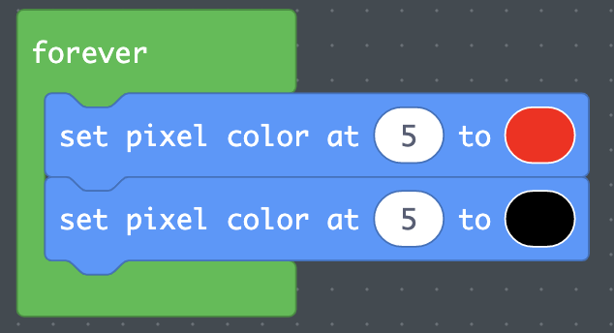

This would be a good chance to explain what the "forever" block does: Each block in it is run one at a time until the bottom is reached, and then the program goes back to the top of the "forever" loop and runs it again. As the name suggests, as long as the Circuit Playground Express is turned on, it will keep running this loop forever.

You should see that this program does make the light blink, but so quickly that it's really just a flicker (if you upload this program to a real Circuit Playground Express, you will see that the power to the LED is turning on and off so quickly that it just appears dim rather than ever being truly on or off). Ask your students: What would we need to change to make it so that it stays on for a bit and then stays off for a bit instead of just flickering?

A good way to do this is to add delays between changes. In the "Loops" category there is a block called "pause" that lets you stop your program for a period of time. Where would you add pause blocks, and how long would you make the pauses, to make the light turn on and off once each second?

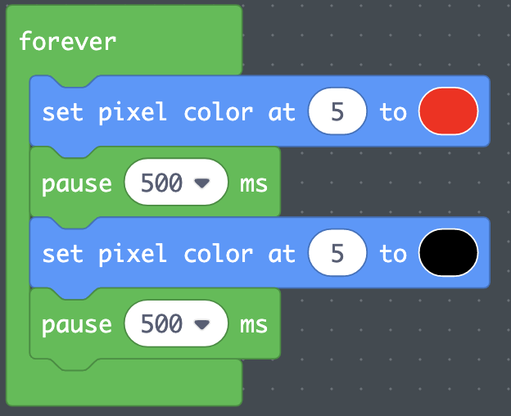

A common student error is to leave out the second pause block and only insert one between the red and black blocks. This error is a good opportunity to re-explore how the program runs in a loop; since the loop goes back to the start immediately upon reaching the end, leaving out that pause means that the LED will be made red immediately after being turned off, so it will appear to just stay red.

This would be a good opportunity to refer back to lesson 01 and teach your class how to download this project and load it onto their Circuit Playground Express. Make sure all of your students have successfully loaded their programs before continuing on to the next programming challenge.

Blinking with an external LED

Now we will add an external LED, and program one of our pads to turn it on and off. We'll wire this circuit up similarly to our previous LED circuit, but with two important differences: We will use one of the programmable pads (this example uses A0, but any of the pads labeled A# will work just file) instead of 3.3v or VOUT; and we will not include a resistor in the circuit. The resistor is not necessary because the programmable pads do not put out as much power as the 3.3v and VOUT pads.

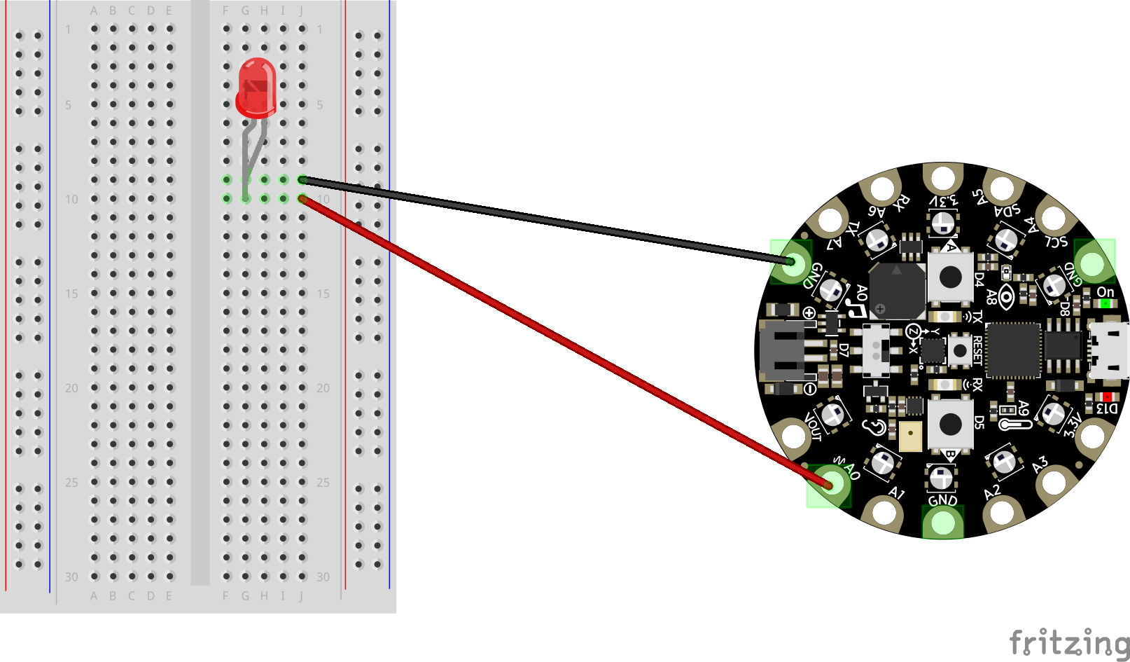

To turn a programmable pad on and off, open the "Advanced" section of the programming block area and select the "PINS" category (we call them "pads" in these lesson plans, but MakeCode calls "pins" because they're analogous to pinholes used in other Adafruit hardware). To turn the power to a pad on, we will use the "Digital write" block. In this block, "high" means "power on" and "low" means "power off." Add these blocks to your existing program like this:

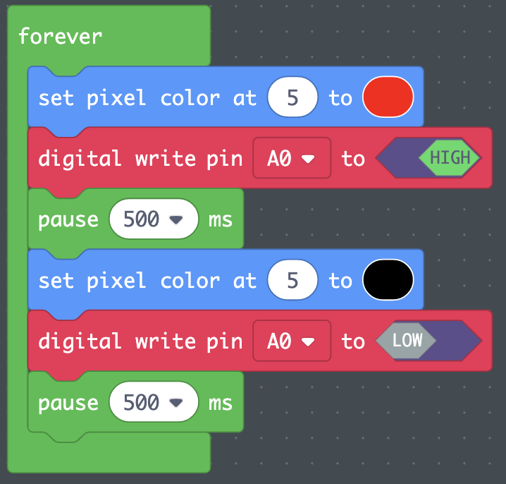

Now when your Circuit Playground Express turns on the on-board LED, it should also be turning on the power to the pin you wired to your external LED. Try loading this program onto your Circuit Playground Express and confirm that the on-board and external LEDs light up and turn off at the same time.

**Stretch Activities:** Can you make two different sets of on-board and external LEDs both light up and turn off at different times? Can you make more? There is an "on shake" block in the "Input" section - what happens if you move your program out of the "forever" loop and into an "on shake" block? Look in the Light section, what other blocks are there? What do they do?